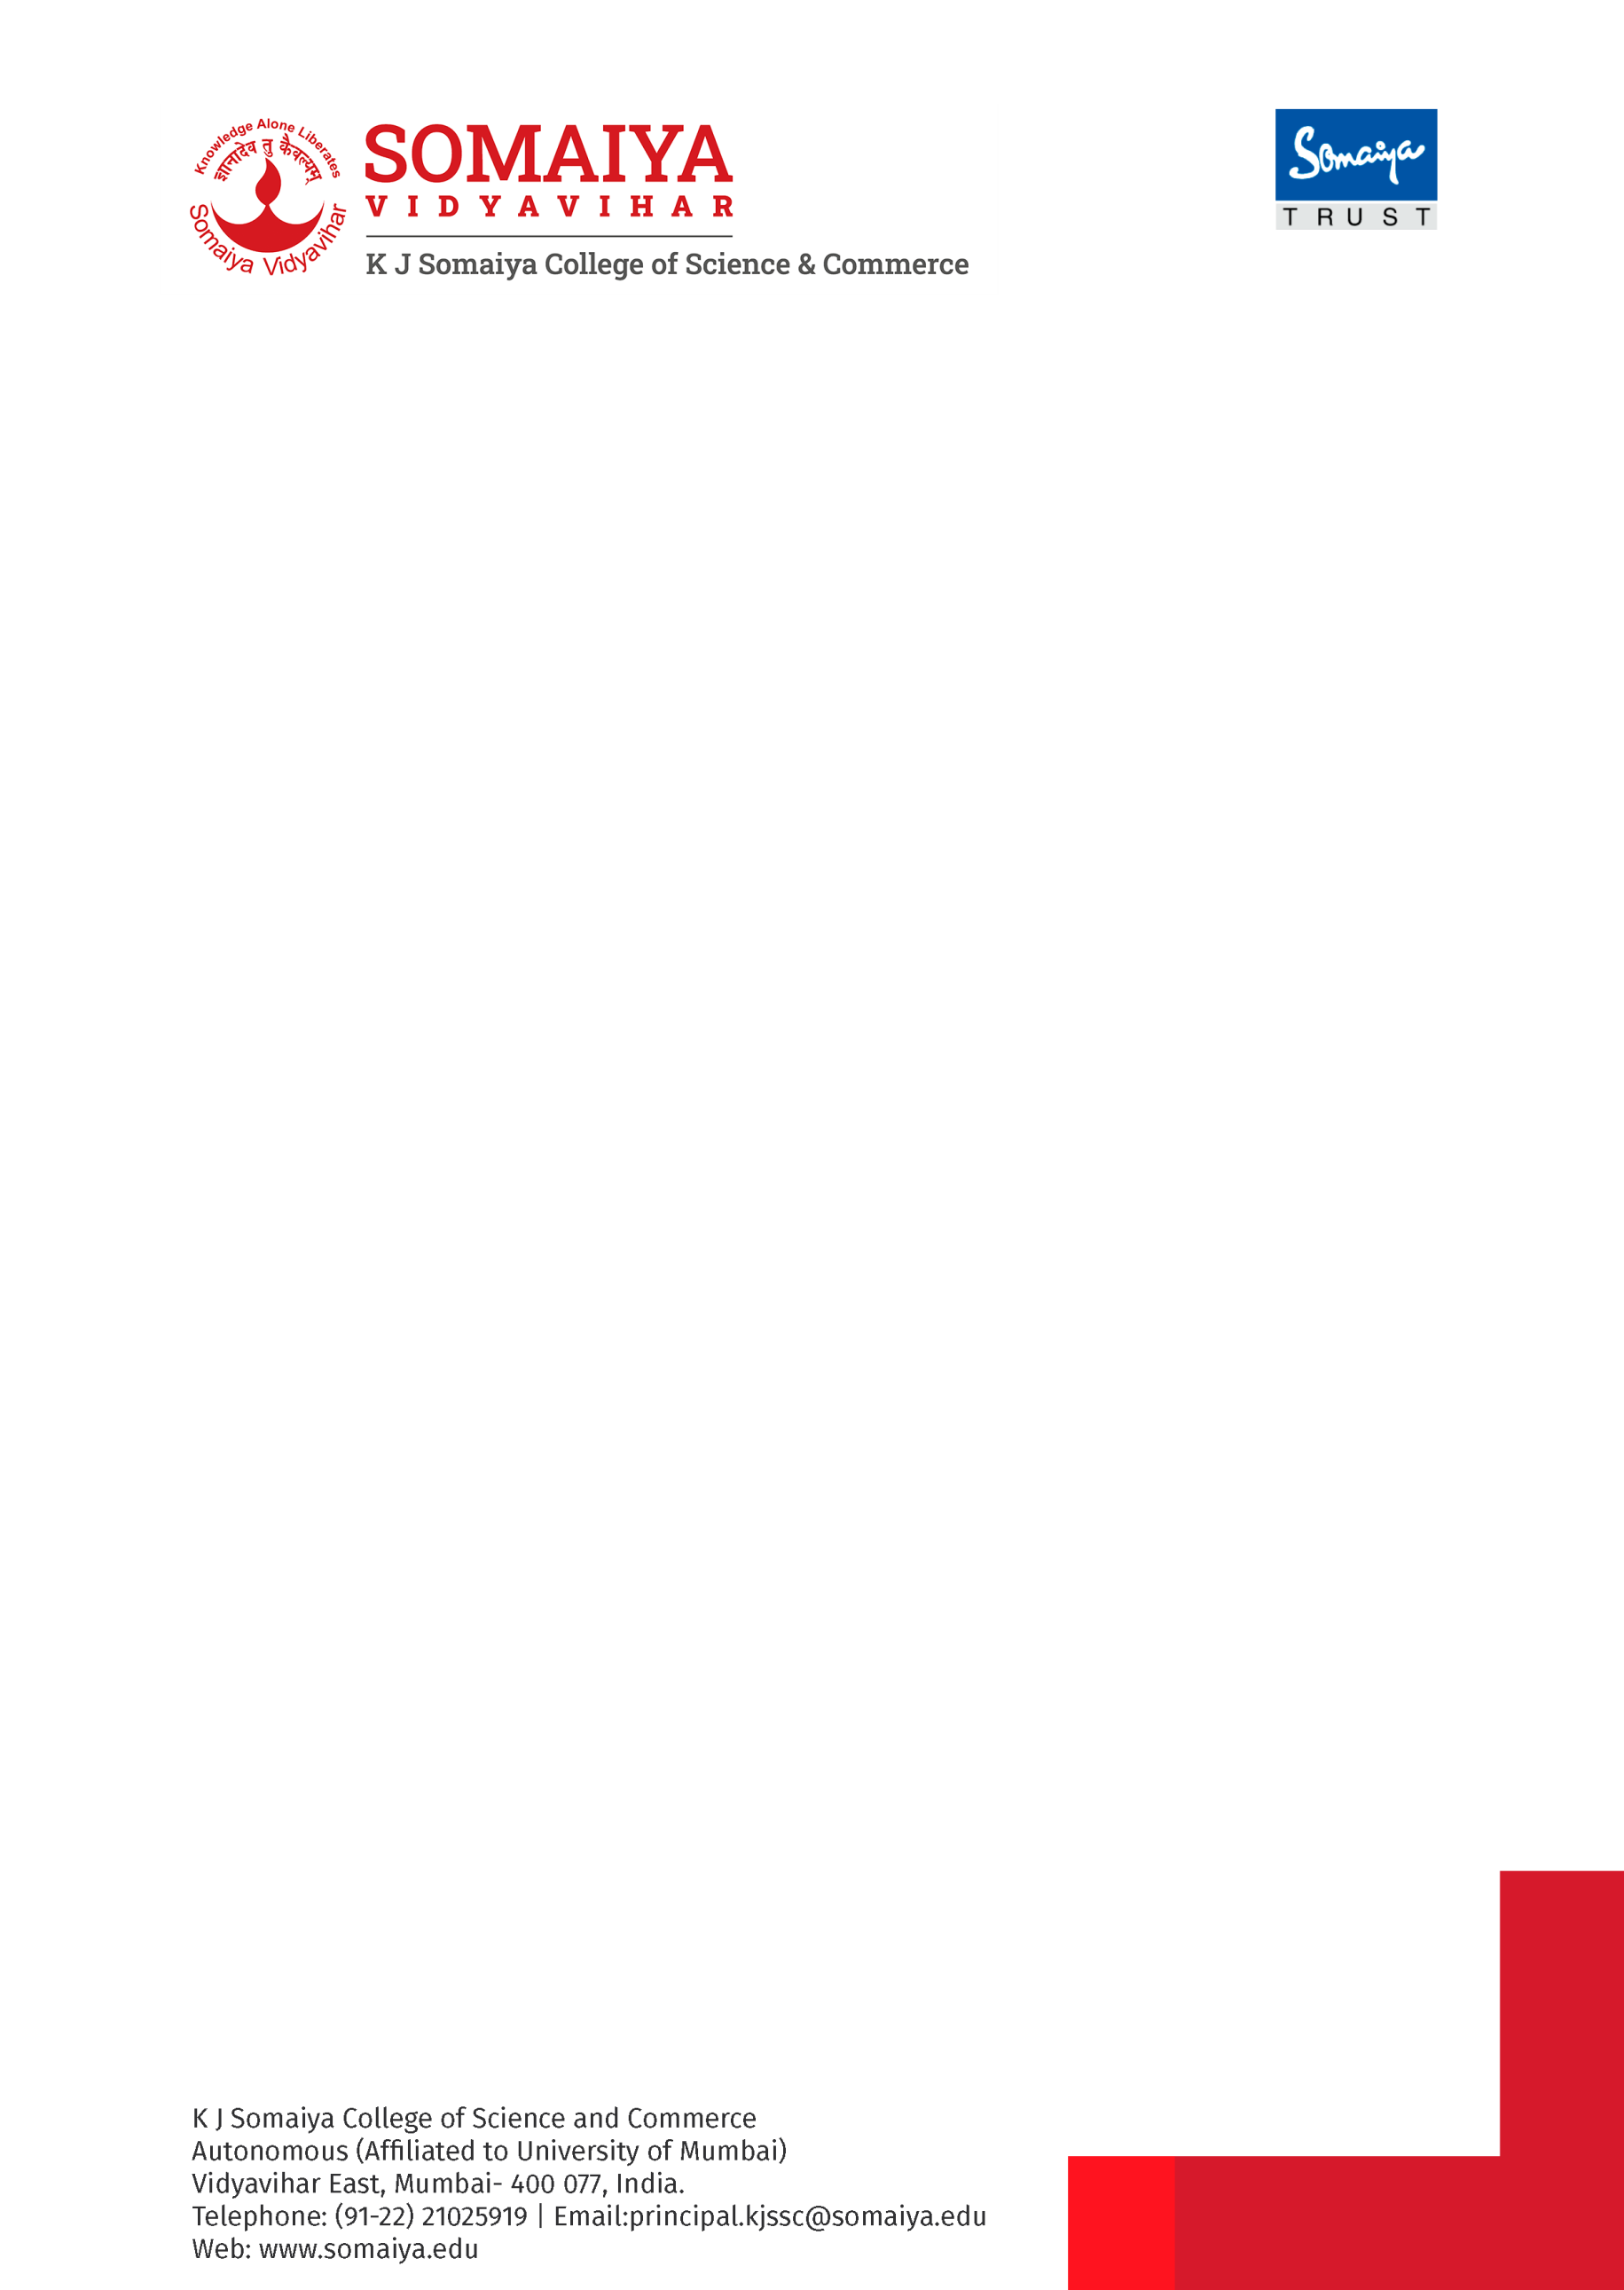

Date:- 12/ 06/2026

RECRUITMENT ADVERTISEMENT

Applications are invited for
POST OF DATA ENTRY OPERATOR
foR the academic year 2026-27
UNAIDED
No. | Department/Subject | Total No. of Posts
1 | Data Entry Operator | 01

The above post is open category post.
The candidates having English & Marathi Knowledge will be preferred.
The age limit for the above post is between 18 yrs to 28 yrs.
Required Qualification Graduation in any discipline with proficiency in Marathi and English.
Typing speed 30 to 40 wpm in Marathi/English, MS- CIT, Advanced Excel. Excellent knowledge & hands on MS Office (Especially Excel & Word).
Applicants who are already employed must send their applications through proper channel supported by required NOC.
_____________________________________________________________________________
Applicants to please note:

- Applicants are requested to forward the duly filled application form (attached to this advertisement) with all supporting documents on recruit.kjssc@somaiya.edu on or before 15 days (till 26th June 2026) from the date of advertisement.
- Applicants are requested to communicate through email only.

---------------------------------------------------------------------------------------------------------------------

Sd/-
PRINCIPAL

PHOTO

APPLICATION FORM

News Paper / WebPortal Date of Advertisement: ____________
Post applied for: ___________________________________________________________

Full Name: ________________________________________________________________
Date of Birth: __________________________________________________________
Mobile No.: ________________________ Email ID :______________________________
Address for Correspondence: __________________________________________________
__________________________________________________________________________
Qualification Details:
Examination Passed | University/Board | Month & year of Passing | Subjects  Offered | Percent--age  of Marks obtained | Class/  Division | Whether the exam. was passed as Regular student or as External student
S.S.C.
H.S.C.
Bachelor’s Degree
Master’s Degree
Other

Details about Experience

Name of Institution where employed previously | Designation of post held | Nature of appointment  Full-time/ Part-time  Permanent/Temporary  Probationary | Nature of work | Period of appointments with dates | Pay scale and Gross salary / Consolidated

Signature of the Candidate

